# Functions

We must define a function in Python in order to call that function by its defined name and to execute it. Calling this function will execute the code, and return the results. *(Biesinger Dirk, FDN_Py_Module_06, retrieved from:* https://canvas.uw.edu/courses/1424622/assignments/5809586?module_item_id=11567708)

An example would be as such:

**Def example_function():** *Here we are defining what print_function() will execute when we call it.*

Print(‘I am testing’)

Print(‘Printing another line’)

Now, we can choose this function to execute the printing code above.

example_function() *which results in:*

I am testing

Printing another line.

# Parameters

We can set arguments to allow the function to process values. There are no limits to how many parameters we can include. *(Biesinger Dirk, FDN_Py_Module_06, retrieved from:* https://canvas.uw.edu/courses/1424622/assignments/5809586?module_item_id=11567708)

For example: StrData = ‘I am testing’. And I can set the def example_function(_) to define this value. When we call the function example_function(strData), it would return the ‘I am testing’.

# Return Values

Return values can either be consumed instantly or assigned to a variable. We can use the results multiple times without having to call the function each time if we capture the results in a variable. Using a function as an expression (e.g. print out the result) requires you to call the function each time. *(Biesinger Dirk, FDN_Py_Module_06, retrieved from:* https://canvas.uw.edu/courses/1424622/assignments/5809586?module_item_id=11567708)

# Assignment 06

In this assignment, the define function was explored. Defining a function allows us to then use that definition to run that function later in the code. For example, if I define what the menu is using def menu, I can then later call on that function ‘menu’ to execute the function that I defined it with. This function menu could be linked to the print() function.

Image captured working in Spyder:

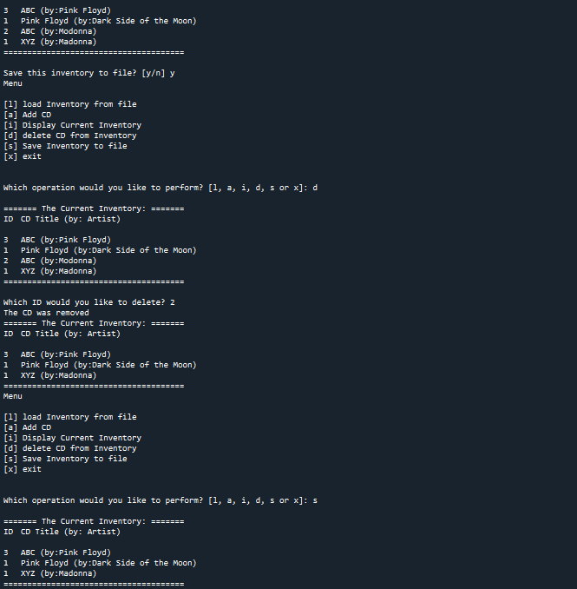

Running Anaconda:

